Stakeholder Engagement Plan

Purpose
The Regional District of Kootenay Boundary (RDKB) is developing a watershed management plan for the Kettle River in British Columbia with broad participation from other stakeholders and agencies. The intended outcome of the Kettle River Watershed Management Plan (KRWMP) is a strategic vision for the watershed with concrete actions to be undertaken by the various agencies and stakeholders who have a role in the management of water and land resources within the basin, including individual citizens. This draft Stakeholder Engagement Plan is intended to guide the Steering Committee, Project Coordinator, and Stakeholder Advisory Group in involving public and stakeholders in the development of the plan.
Our overall objectives for stakeholder engagement include:
- Offer a variety of opportunities for the public to be involved at every phase of the planning process
- Understand and take into consideration broad public input about concerns and priorities
- Increase public awareness about the watershed, its issues, and the policies being considered and implemented
- Increase public support for watershed planning using educational tools and constructive, meaningful dialogue

Key messages about Stakeholder Engagement
- The public will have many opportunities to participate, learn about the watershed, and give feedback on issues and recommendations. This is a transparent, stakeholder-led planning process.
- The purpose of the Stakeholder Advisory Group is to provide advice on watershed issues, goals and recommendations, and to act as a hub of public engagement. The 30-member Advisory Group represents the full spectrum of stakeholders from across the watershed.
- All public concerns and issues about the watershed are important and will be considered by the Stakeholder Advisory Group. We will seek to understand issues in terms of causes, effects, scope and jurisdiction. The Advisory Group will, with public input, prioritize issues and categorize them for: a) further study; b) recommendations to local government; c) recommendations to higher levels of government; and d) education, extension, and voluntary stewardship opportunities by stakeholders.
- Funding for this project has been obtained from the BC Gas Tax Fund [and other partners]. There is also considerable in-kind support from the provincial and local governments as well as all members of the Advisory Group and Technical Advisory Committee. RDKB recognizes the value of all contributions and will ensure the highest and best use of these resources.

Stakeholders
In various ways members of the public, agencies, businesses and other organizations impact and are impacted by the health and condition of the watershed. This is what is meant by our theme, “The Kettle River Starts Here” – the watershed isn’t somewhere else or someone else’s responsibility, but begins with each of our footprints and backyards.
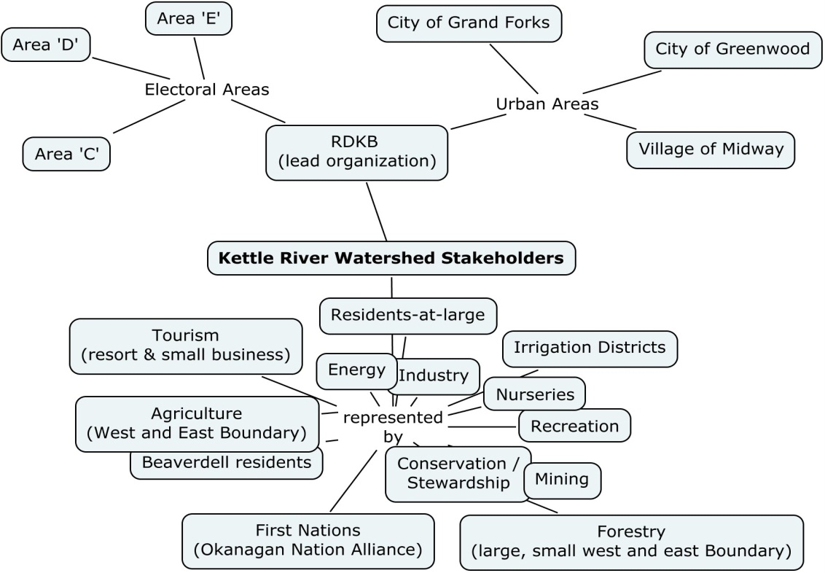
Stakeholders for the Kettle River Watershed include all groups or individuals who may affect or be affected by water quantity, water quality, aquatic ecosystems or watershed management activities within the Kettle River Watershed. What we mean by “stakeholder engagement” is using a variety of procedures to enable diverse members of the public to be active participants in deliberating about issues and solutions related to the Kettle River watershed.
Figure 1. Stakeholder Advisory Committee sector representation
This engagement plan takes a sector-based approach, where stakeholders are involved in developing the watershed plan based on the organization or sector(s) they are from as well as their expertise, individual interest or position in the community. The composition of the Stakeholder Advisory Group (SAG) includes representatives from sectors including municipal governments (rural and urban), tourism, agriculture, First Nations, forestry, industry, nurseries, recreation, Irrigation Districts, mining, energy, stewardship, and residents at large (Figure 1).
As noted in their Terms of Reference, a key role of the SAG is to be a hub for public involvement throughout the planning process. This means that they will look for opportunities to connect with other organizations and individuals who may have an interest in the Kettle River watershed. They will also actively promote public events and planning activities, and share information broadly across their networks. Specific activities to be promoted through the SAG are discussed in Section 0.
The influence exerted by stakeholders can impact the planning process positively or negatively as they attempt to satisfy their interests. Issues such as the use of power, legitimacy, level of interest, and collaboration or conflict require careful consideration. At each stage in the planning process the project coordinator and steering committee will assess these factors and adjust engagement strategies as required:
- What level of collaboration and/or conflict exists among stakeholders – can this be used to constructively influence project outcomes?
- Is the legitimacy of stakeholders (rights, responsibilities and resolve related to the project) recognized by the other parties?
- Are the stakeholders’ interests in the project’s outcomes high, low or neutral with respect to net gains or losses?
- Do the stakeholders have the power to affect the project outcomes through control of economic wealth, political authority, fear through intimidation, communication, etc?

Engagement Commitments
In a watershed management planning process, there are several levels of community engagement that need to be strategically incorporated throughout the project (Table 1). Different stakeholders have different needs and interests in terms of how we involve them. For instance, certain industrial stakeholders may wish to be informed during initial stages, but consulted when the project evolves or focuses on issues that concern them. Our challenge is to strive to realistically address the various needs of stakeholders in order to develop a rigorous, relevant, and publicly-supported plan.

Table 1: Levels of Stakeholder Engagement, commitments, and example activities.
Level of involvement | What it means | Commitment | Example / potential activities
Inform | One way communication providing balanced and objective information to assist understanding about something that is going to happen or has happened | We will keep you informed, sharing information about the watershed and inform you about opportunities to be involved | Web site updates, news stories, presentations
Consult | Two way communications designed to obtain public feedback about ideas on rationale, alternatives and proposals to inform decision-making | We will keep you informed, listen to and acknowledge concerns and provide feedback on how public input influenced the decision. | Surveys (web, mailed), open houses, public meetings, booths at public events
Involve | Participatory Process designed to help identify issues and views to ensure that concerns and aspirations are understood and considered prior to decision-making | We will work with you to ensure that your concerns and aspirations are directly reflected in the alternatives developed and provide feedback on how public input influenced the decision. | Special meetings, workshops, community mapping events
Collaborate | Working together to develop understanding of all issues and interests to work out alternatives and identify preferred solutions | We will look to you for direct advice and innovation in formulating solutions and incorporate your advice into decisions to the maximum extent possible | Stakeholder Advisory Group, planning charrettes

Activities
This engagement strategy outlines a number of opportunities for engaging the general public and specific audiences to be carried out by the Project Coordinator and members of the Stakeholder Advisory Group. Each activity description includes an overview of the engagement activity, overall objectives, and specific details / requirements. Where appropriate individual activity plans with detailed objectives and methodology will be developed prior to commencement (i.e. survey analysis).

Press releases and stories
Regular news stories through various outlets at all stages through the planning process.
Objective: Keep the general public and other stakeholders informed about planning progress, milestones, issues being addressed and opportunities to be more involved.
- Requirements
  - Send to: newspapers (Grand Forks Gazette, Boundary Sentinel, Boundary Creek Times, Christina Lake News, Boundary Communicator); radio (Mountain FM, EZRock Trail, CBC Kelowna); and display on website
  - Always reference (with contact info) Chairperson & Stakeholder Advisory Committee, Project Coordinator, and Director of Planning & Development
- Releases:
  - Kick-off release with key messages (June 2012)
  - Stories (2-3) on major findings from State of the Watershed (summer-fall 2012)
  - Story on opportunities to be involved looking forward to specific events (Summer 2012 and 2013)
  - Story on each major public event or special meeting
  - Stories (2-3) on major issues and types of recommendations to address them (fall 2013)
  - Stories (2) on final plan and implementation strategy (spring 2014)

Website and social media
Website to be updated 3-4 times per month with event information, related news stories, or relevant information. All meeting information to be put up before and after meetings when circulated to Advisory Group.
Objectives:
- Keep the general public and other stakeholders informed about planning progress, milestones, issues being addressed and opportunities to be more involved.
- Provide a place to document the planning process, share information, and generate online interest for all stakeholders.

Brochures, pamphlets & presentations
A series of short publications for distribution to public venues across the region.
Objectives:
- Provide general planning and educational information to stakeholders and general public who are attending public events / venues and have not been reached through other means
- Create visibility and credibility for RDKB and the planning process
Distribute pamphlets to: libraries; visitor/travel information centres; coffee shops; community organizations; campgrounds; and other sites identified by Project Coordinator and Advisory Group members. Prepare “off-the-shelf” presentation of 12-15 power point slides for advisory group members to use with their organizations and contacts.

Surveys & questionnaires
A series of surveys and questionnaires will be prepared, disseminated and analyzed at key milestones in the planning process.
Objective: Consult with general public and all stakeholders to understand and incorporate concerns about issues and feedback about planning recommendations
- Survey 1 – “Hopes for the Kettle River Watershed Management Plan”. Short survey that allows stakeholders to articulate needs and aspirations for the KRWMP planning process and outcomes, and to sign up for email updates. Initiated in June and to be closed at the end of August.
- Survey 2 – A short survey (online and in print) with questions about watershed values, issues/concerns, and success stories/opportunities (fall 2012). Information to feed into “Vision” document, issues analysis and recommendations development. Survey to be patterned after Grand River Conservation’s 2012 survey.
- Survey 3 – Survey to gather input on draft recommendations (fall 2013). Patterned after Vermilion River watershed survey.
- Survey 4 – Feedback questionnaire on Draft Watershed Plan & Implementation Strategy (Spring 2014)

Community events
Project coordinator to work with Advisory Group to identify opportunities for presentations, information tables, or attending at community events such as Kettle River Fest, Rock Creek Fall Fair, Grand Forks Farmer’s Market and Grand Forks Fall Fair. Coordinator will also connect with teachers for school presentations and relevant activities.
Objectives:
- Keep general public and stakeholders informed
- Connect directly with stakeholders in different areas of the watershed and from different backgrounds
- Provide general education and outreach to interested members of the public and to engage people in discussions about the watershed (education and outreach).
- Gather feedback from the public on watershed values, issues, and success stories/opportunities

KRWMP Events
A series of open houses, public meetings, and special events / workshops for education & outreach, building understanding, and learning from the community. Specific events include:
- “Rethinking our Water Ways” special meeting
  - October 12 meeting for Advisory Group, guests, and interested public to build our understanding and capacity for watershed planning
  - Presenters from Fraser Basin Council, Okanagan Basin Water Board, and the Kettle River watershed on issues & roles in watershed planning, governance, and success stories
  - Discussions about issues, challenges and opportunities in the Kettle River Watershed
- Watershed community mapping
  - Half-day events/drop in sessions in Christina Lake, Grand Forks, Greenwood, and Rock Creek to be scheduled in late fall/early winter. Outcomes include building understanding and learning from the community about watershed issues. Will use base maps of the watershed and small group discussions to record information from community members about:
    - Valuable places & watershed-related amenities
    - Issues of concern (location, scope & impact)
    - Success stories and opportunities for watershed protection and restoration
  - An online map interface for displaying (and potentially recording) community map information will be considered. Output from the mapping will be used in the “Vision” document and special meeting (late 2012/early 2013), for use in the issues analysis, and for information towards developing recommendations for resolving issues
- Watershed Visioning
  - Special meeting in winter 2012 to articulate a community vision for the Kettle River Watershed and to outline planning goals for surface water, ground water, and aquatic ecosystem health
  - Meeting will consider results from surveys, mapping, and early events to develop draft statements
- Watershed Issues Analysis
  - Special meeting(s) (winter 2012/2013) to:
    - characterize issues in terms of causes, impacts, trends, geographic extent, management/policy context, opportunities, and information availability.
    - Prioritize issues for addressing in watershed plan
- Recommendations development
  - Special meeting(s)/workshops for summer-fall 2013 to identify solutions, evaluate alternatives and develop management directions, policies and actions to resolve issues and achieve goals and objectives.
- Open houses
  - Fall 2013 to consult with public on draft recommendations
  - Spring 2013 to consult with public on draft Watershed Management Plan & Implementation Strategy

Stakeholder Advisory Committee Terms of Reference
Chevalier, JM (2004) The social analysis system, Carleton University, Ottawa. Available online: http://www.sas-pm.com/pdfs/Social_analysis_CLIP.pdf.
http://www.dse.vic.gov.au/effective-engagement
Adapted from http://www.dse.vic.gov.au/effective-engagement/resources/download-effective-engagement.
http://www.grandriver.ca/waterplan/Feb2012_Poll_results.pdf
http://www.nswa.ab.ca/vermilion/discussion-survey
“Special Meetings” are meetings of the Stakeholder Advisory Group (and other guests) held in a half-day to full-day workshop format instead of the normal 2-hour evening meeting.

